What
are you
NEXTING?

#TREbit – ANTICIPATION ADVANTAGE
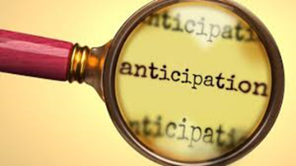
Positive Anticipation, aka: dreaming, thinking, planning, or preparing.
The holiday season can provide opportunities for positive anticipation in thinking about time with loved ones, special events, thoughts about a person opening a gift from you, waiting to hear a favorite song or see a favorite show, or thoughts about what the new year may bring.
“Research shows that positively anticipating the future is a highly effective way to create positive emotions… Studies have shown that anticipating future events can be more pleasurable than the events themselves. Thinking about the future involves mentally simulating future scenarios, which activates the brain's reward system and releases dopamine, a neurotransmitter linked to pleasure and happiness.” Psychology Today https://www.psychologytoday.com/us/blog/living-forward/202405/finding-joy-how-positive-anticipation-boosts-your-happiness
James Clear in his book, “Atomic Habits” states, “It is the anticipation of a reward—not the fulfillment of it—that gets us to take action. The greater the anticipation, the greater the dopamine spike.”

From Shawn Achor’s book, “The Happiness Advantage”, “One study found that people who just thought about watching their favorite movie actually raised their endorphin levels by 27 percent. Often,
the most enjoyable part of an activity is the anticipation.”
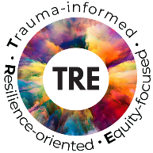
Activating the Anticipation Advantage can happen any time and in a wide variety of situations. Think about looking forward to an upcoming vacation or doing something on your bucket list.
Positive Anticipation is a powerful tool for self-care as well as a tool to share with individuals in service, friends and family members.

