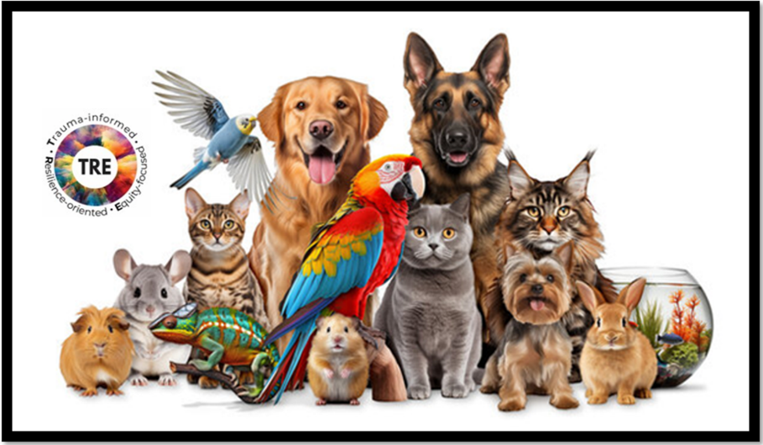
#TREbit
PETS
PROVIDE
PROFOUND
PEACE &
PURPOSE

Have you ever noticed how spending time with your pet instantly boosts your mood? Whether it's your dog wagging its tail when you walk in the door, your cat purring on your lap, or even watching fish swim in an aquarium? Animals can have a wonderful effect on our wellbeing – and there's science behind it!

Key Aspects of Pets Providing Peace:
- Stress Reduction: Interacting with pets lowers blood pressure and reduces anxiety, often bringing a sense of calm.
- Unconditional Support: They provide a non-judgmental, safe, and affectionate presence, which is invaluable for mental health.
- Emotional Regulation: Pets can sense human emotions and respond with comforting, calming behaviors. Their non-judgmental presence combats loneliness and aids emotional healing.
Key Aspects of Pets Providing Purpose:
- Routine and Structure: The necessity of feeding, grooming, and walking pets brings consistency and order, which can be crucial for managing daily life.


The Neuroscience Behind the Profound Positive Impact of Pets
Numerous research studies have been conducted on the positive impact of pets. This #TREbit is just an introduction to the topic based on studies by the National Institute of Health (NIH). As well as research showing that furry family members can help us heal from trauma and build our resilience.

Interaction with pets of any type can lower cortisol, blood pressure, and heart rate, promoting a calmer, more stable brain state. Studies have shown that petting a dog or cat for just 10 minutes can significantly reduce cortisol levels. Even brief interactions with animals can calm your autonomic nervous system, slowing your heart rate and lowering your blood pressure.
Interaction with pets increases calming neurotransmitters (oxytocin, serotonin). Oxytocin has a powerful effect on our mental health, reducing stress and anxiety and promoting feelings of trust and bonding. So when your dog looks at you with those big eyes, or your cat rubs against your leg, your brain starts to flood with a chemical that cheers you up and calms you down.
Owning or interacting with pets may even change your brain structure and function! Some studies using MRI scans have found that people with strong emotional bonds with their pets have increased grey matter volume in brain areas related to emotion regulation and empathy, like the amygdala and prefrontal cortex. Studies indicate that dog owners over 65 may have a 40% lower risk of developing dementia, with pet ownership potentially preserving the hippocampus.

